SOFTWARE TESTING ASSIGMENT

MODULE -01

1. what is SDLC!

Structure imposed on the development of a software of product that define the process for planning testing, Documentation ,deployment and ongoing maintenance.

1. what is agile methodology!

It was way to manage a project by breaking it up into several phase.it was involves constant collaboration with stakeholders and continuous improvement at every stage.

Once the work begins, teams working simultaneously on various areas like process of planning ,requirements analysis,design, coding,unit testing and acceptance testing.

*Agile model is combination of iterative and incremental process.

*Agile methods break the product into small incremental builds.

*these builds are provided in iterations.

**Manifesto principle agile**

**\*individuals and interactions**

**\*working software**

**\*customer collabroration**

**\*Responding to change**

1. **What is SRS!**

SRS= software requirements specification

Documents that describes what the software do and how it will be expected to perform. It also describes the function product needs to fulfill all stakeholders needs.

**TPYES OF REQUIREMENTS**

**\*Customer requirements**

**\*Functional requirements**

**\*Non-Functional Requirements**

1. **What is oops!**

**Oops= Object-Oriented Programming**

Opps A computer programming model that organizer software design around data or objects rather than functions and logic.

1. **Write basic Concepts of oops**
2. Objects
3. Class
4. Encapsulation
5. Abstraction
6. Polymorphism

-overriding

- overloading

1. **What is objects**

Objects are things you think about first in designing a program and they are also the units of code that are eventually derived from the process.

An objects is an instance of a class a class is a template or blueprint form which objects are created.so an objects is the instance of a class.

Everything in this world is an object-

A bus , a mobile ,a table ( everything)

There are two parts of an object---- (Object = data + methods)

1. **What is class!**

A class is a blueprint that defines the variables and the methods common to all objects of a certain kind.

A class represents an abstraction of the object and abstracts the properties and behavior of that object.

Ex.

1. **What is encapsulation !**

Encapsulation is a process of wrapping code and data together into single unit.

Encapsulation enables data hiding,hiding irrelevant information form the users of a class and exposing only the relevant details bu the users.

**9)What is inheritance !**

While genetic information is passed on form parent to child.

* A subclass I also the tpye of superclass.

*inheritance is the process of creating a new class, called the derived,from the exissting classs,called the base class.

1. **what is polymorphism!**

**\***polymorphism means many forms of single thing.

*the ability to change form is khown as polymorphism.

*polymorphism is the ability of programming language to present the same interface for several different underlying data types.

*tow type of polymorphism.

1. **Compile time polymorphism (overloading)**

**2)Run time polymorphism (overriding)**

**\*\* Compile time polymorphism (overloading**

Static binding

**Compile time polymorphism (overloading)**

**Dynamice binding**

1. **Draw Use case on Online book shopping.**

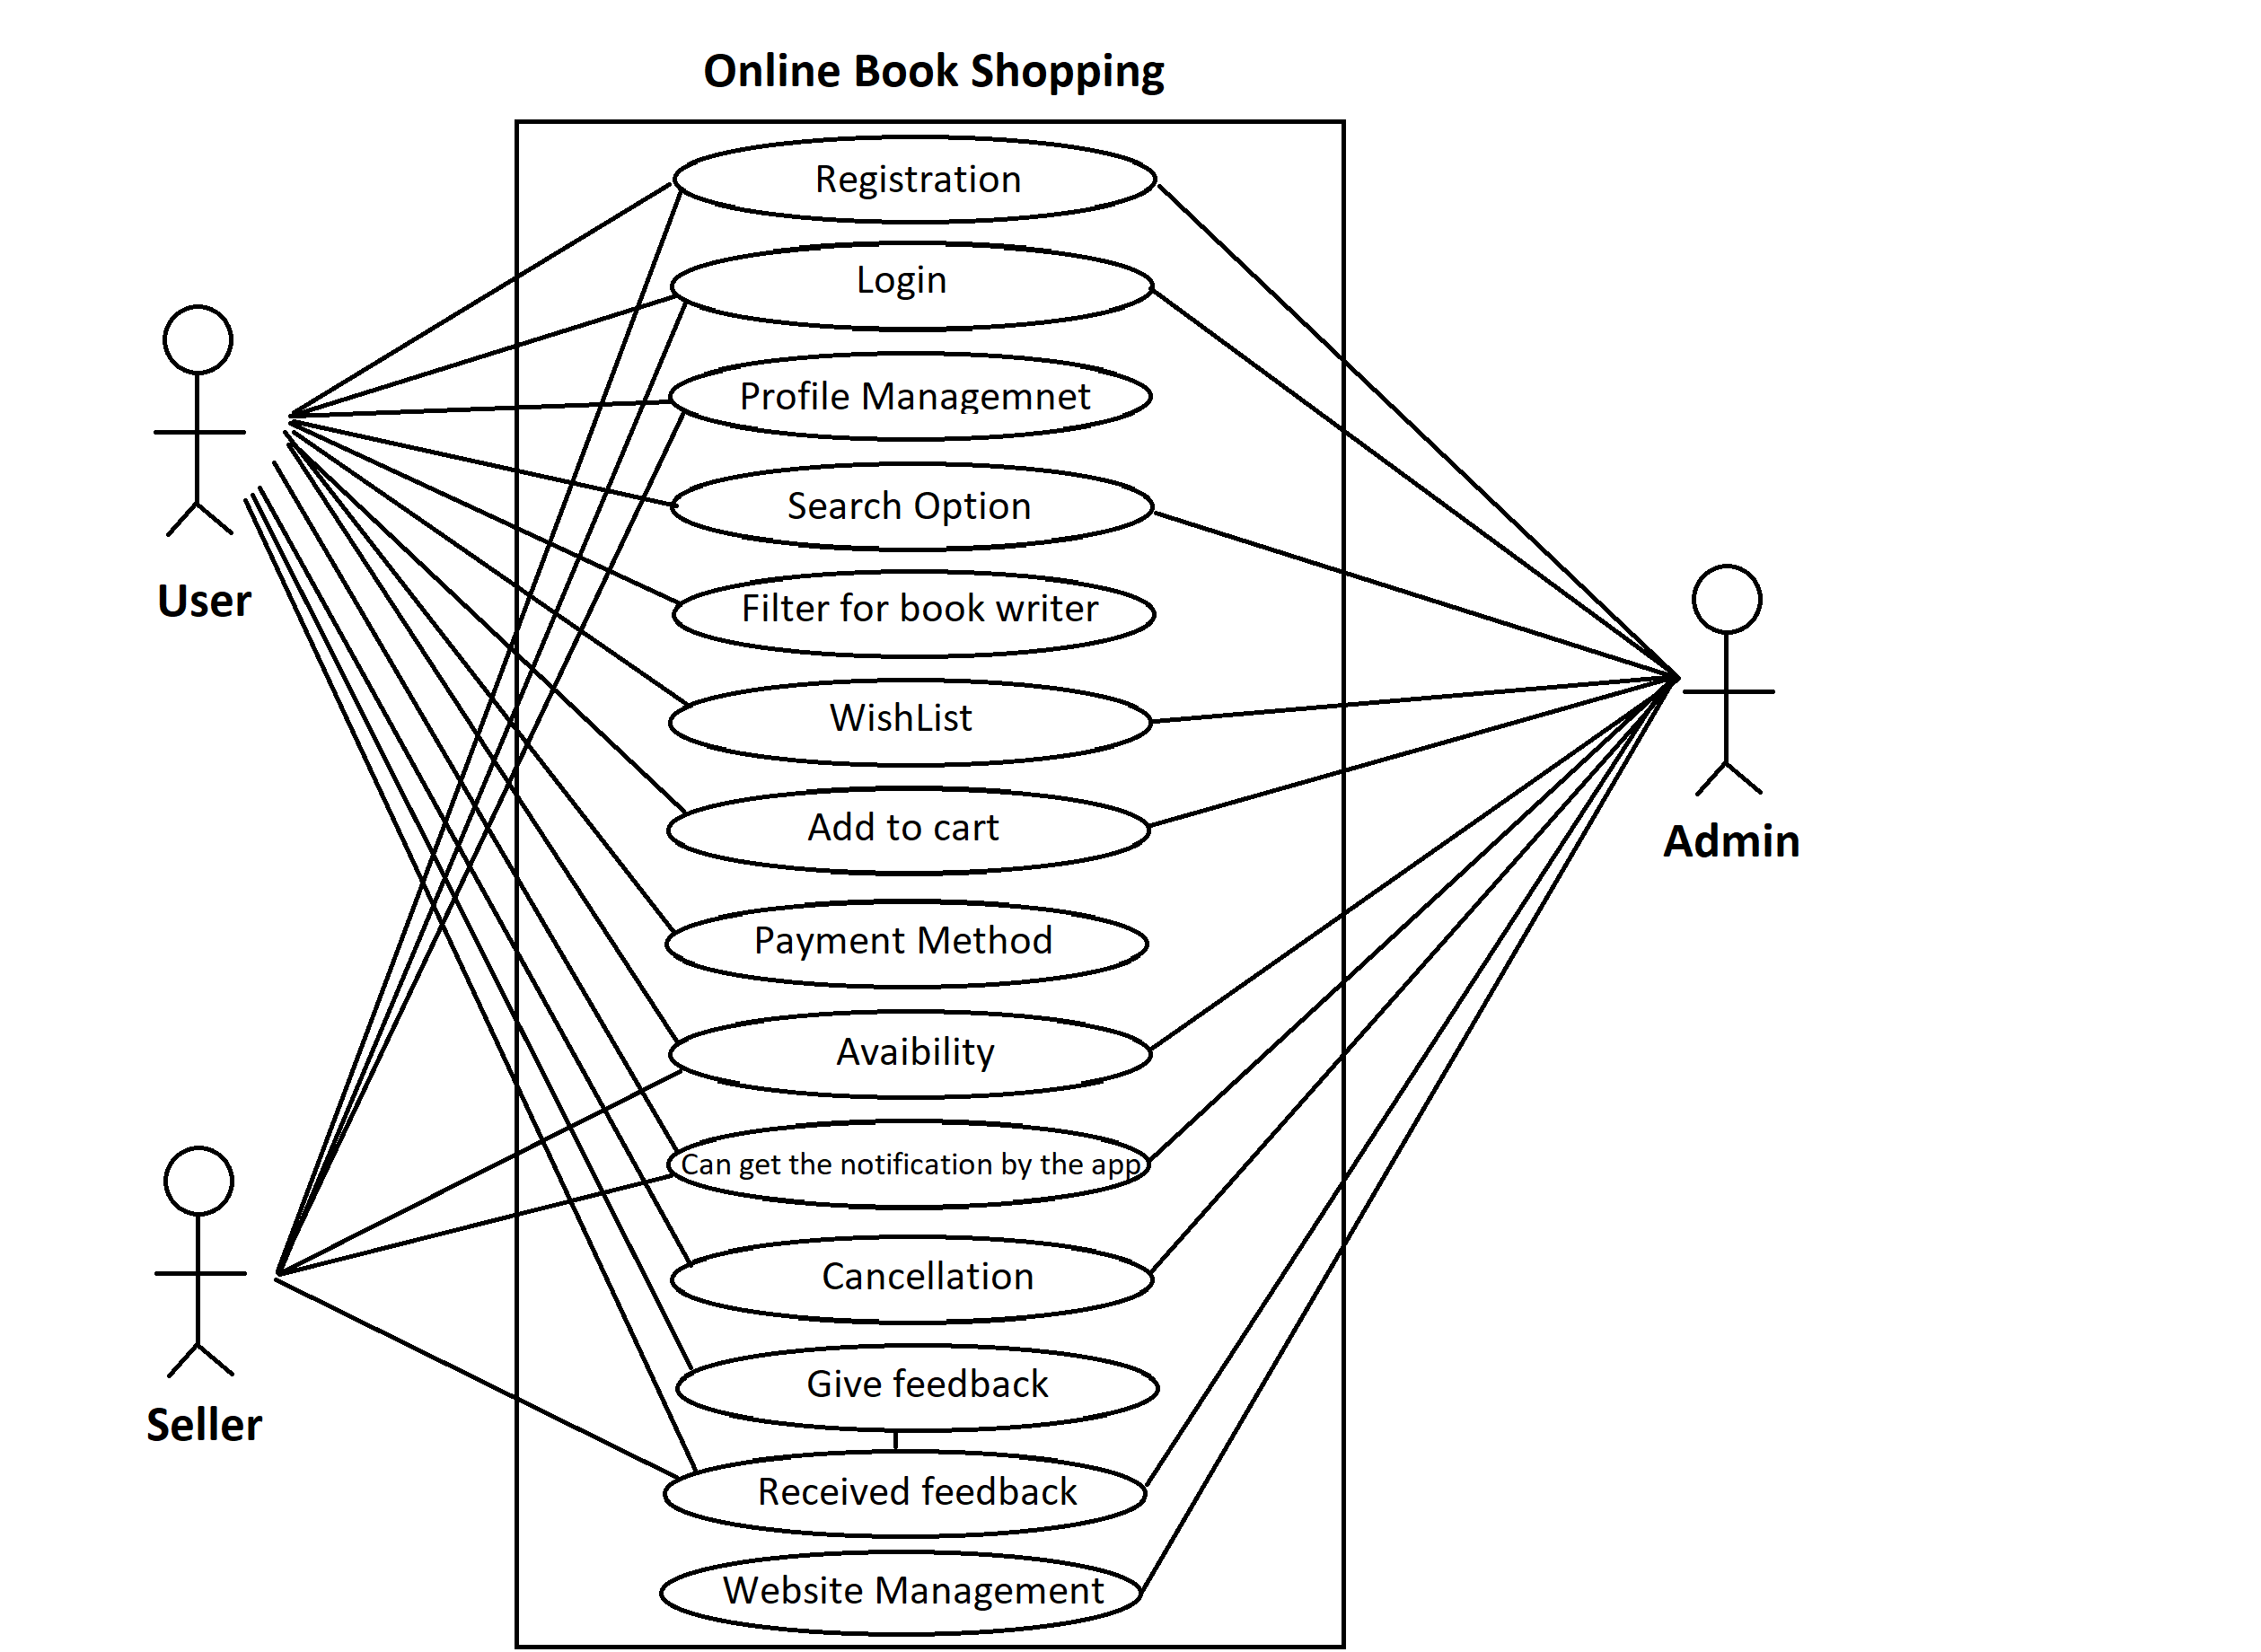

1. **15)Draw Use case on online bill payment system (Paytm)**

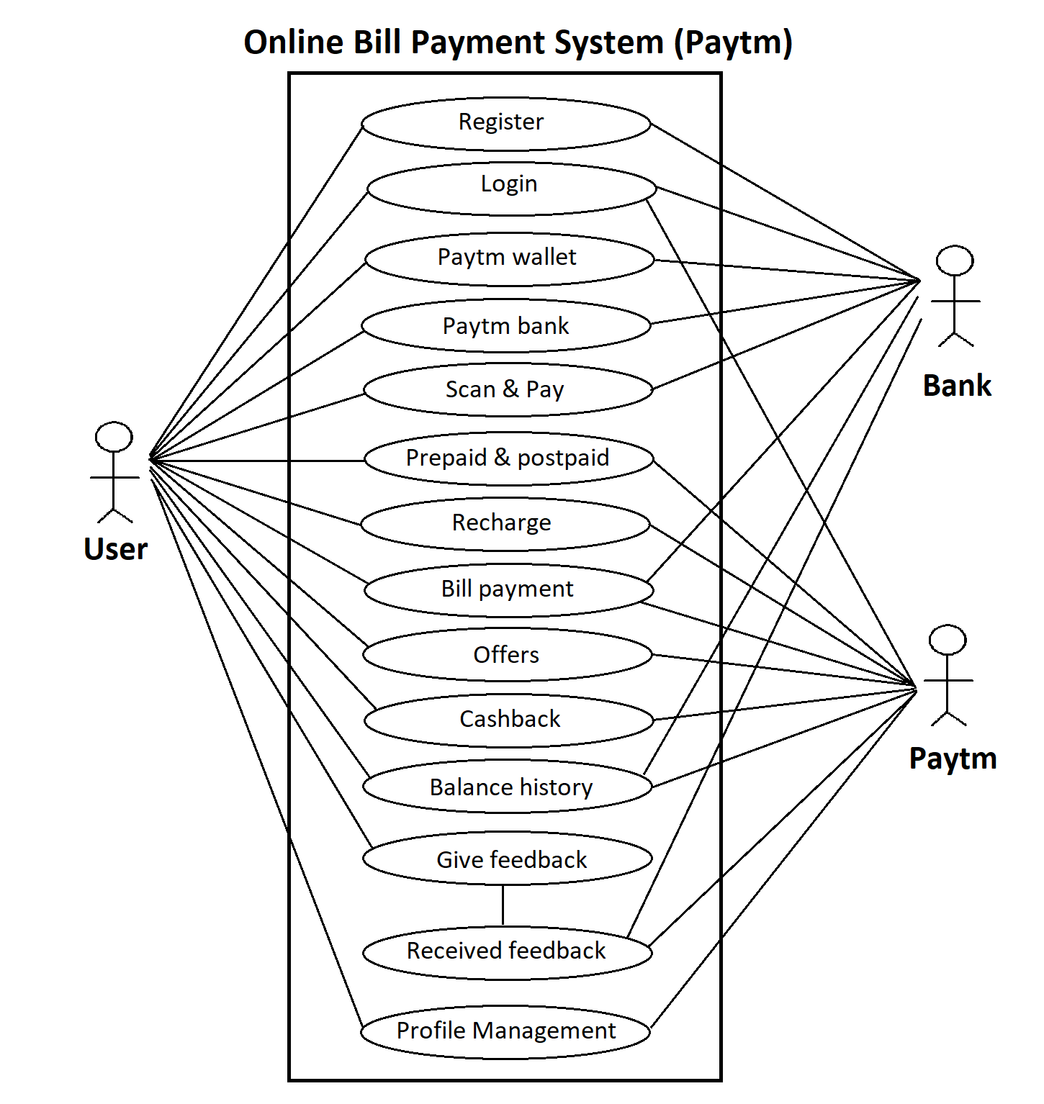

1. **Write SDLC phases with basic introduction.**

**Analysis**: in this phase analyst interact with stakeholders to develop the model and specify the requirements documents.

**DESIGN:** during this phase developer and technical designer create initial level design for the software and system.

**TESTING:** tester test the software to validation the solution against the requirement to make sure that the software is solving the needs draing.

**MAINTENANCE:** after software is ready or on live environment the system is in maintenance mode and repair defects and adapt the solution to the new requirement.

**17 Explain phases on the waterfall model.**

The Waterfall model is the earliest SDLC approach that was used for software development.

The waterfall model is a classical model used in system development life cycle to create a system with a linear and sequential approach. It is termed as waterfall because the model develops systematically from one phase to another in a downward fashion.

There are five-stage of waterfall model, which is based on the requirements.

**ANALYSIS---> DESIGN---->IMPLEMENTATION--->TESTING--->MAINTENANCE**

1. **Write phase of spiral model.**

*Spiral Model is a risk-driven software development process model.

* It is a combination of waterfall model and iterative model. Spiral Model helps to adopt software development elements of multiple process models for the software project based on unique risk patterns ensuring efficient development process.

**Four type of phases**

1. **Planning:** In this phase, determine objectives and find alternate solutions. This phase includes requirement gathering and analysis. Based on the requirements, objectives are defined and different alternate solutions are proposed.
2. **Risk Analysis:** In this phase, all the proposed solutions are analyzed and any potential risk is identified, analyzed, and resolved
3. **Engineering:** In this phase, includes the actual implementation of the different features. All the implemented features are then verified with thorough testing.
4. **Customer evaluation:** In this phase, Review and planning of the next phase.The software is evaluated by the customer. It also includes risk identification and monitoring like cost overrun or schedule slippage and after that planning of the next phase is started.

**19)Write agile manifesto principles**

* **Individuals and interactions** - in agile development, self-organization and motivation are important, as are interactions like co-location and pair programming.
* **Working software** - Demo working software is considered the best means of communication with the customer to understand their requirement, instead of just depending on documentation.
* **Customer collaboration** - As the requirements cannot be gathered completely in the beginning of the project due to various factors, continuous customer interaction is very important to get proper product requirements.
* **Responding to change** - agile development is focused on quick responses to change and continuous development.

1. **Explain working methodology of agile model and also write pros and cons.**

Agile methodology is a project management framework, used by teams to alliterative and incrementally complete tasks and projects. In most cases agile is implemented in the form of a working framework known as scrum, over short work beats called sprints.

**ADVANTEGE**

1. Customer satisfaction is rapid, continuous development and delivery of useful software.
2. Customer ,developer and product owner interact regularly with each other.
3. A face-to-face conversation to technical excellence and good design.
4. Even late changes is requirements circumstances.

**Disadvantage:**

1. **It is not use full for small development projects.**
2. **It requires an expert project member to tack crucial decisions in the meeting.**
3. **The project can quickly go out off track if the project manager is not clear about acquirement and what outcome they want.**
4. **Not suitable for handling complex dependencies.**

**24 Draw use case on Online** 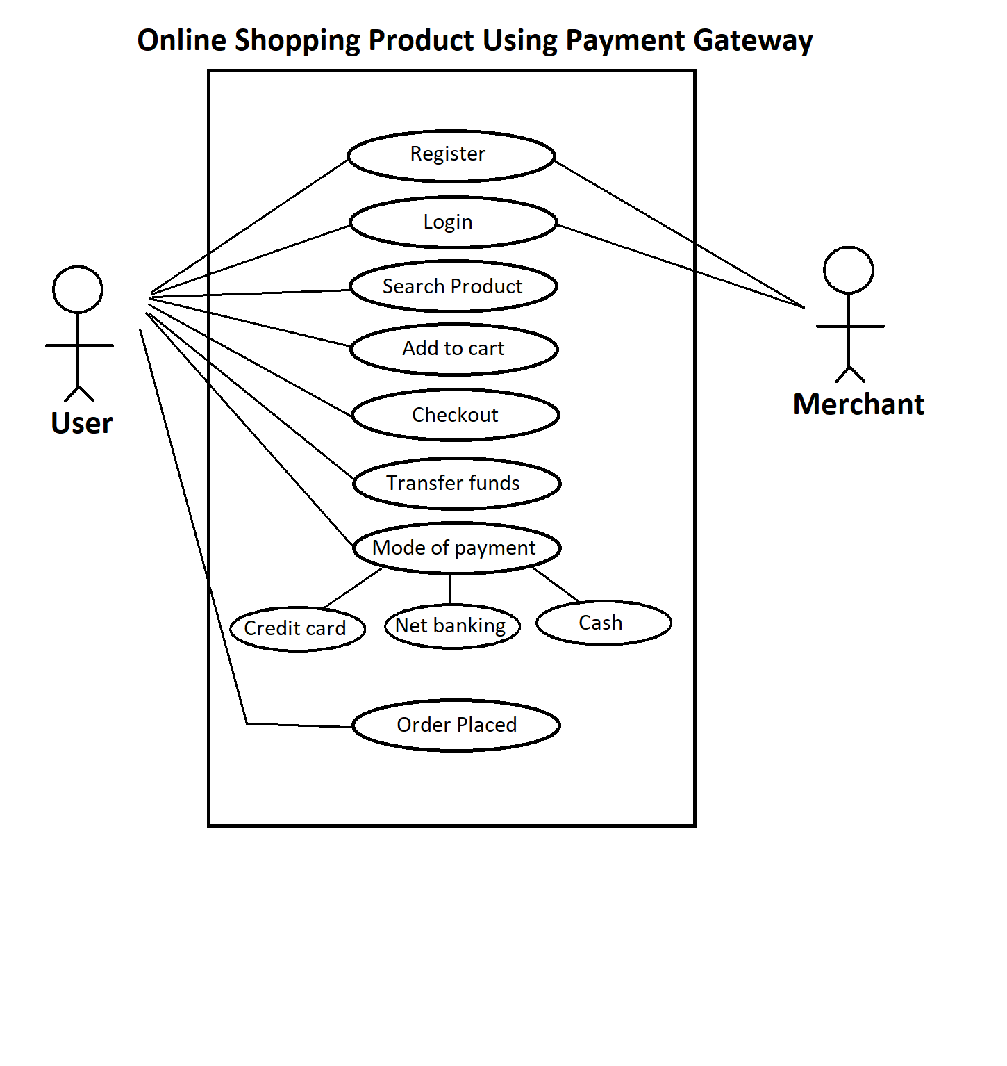

**25 Draw use case on Online shopping product using payment gateway.**

